**TCP Attack Lab**

**Task 1: SYN Flooding Attack**

In this task we first consider that our server is ’10.0.2.9’, the user is ’10.0.2.7’ and the attacker’s ip is ’10.0.2.8’. We will first telnet ’10.0.2.7’ (user) to ‘10.0.2.9’ (server).

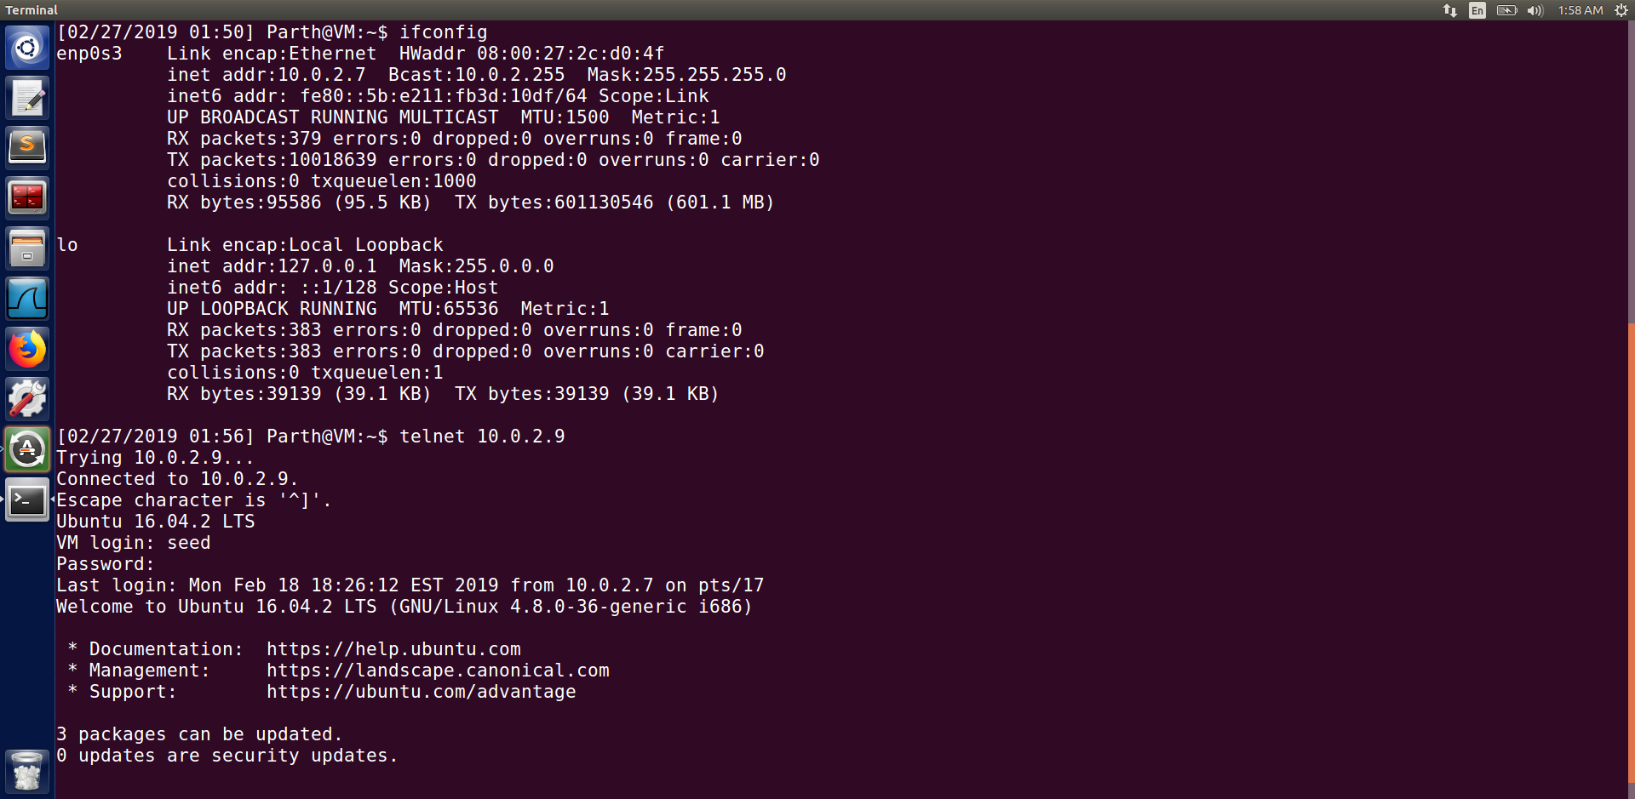

We also turn off the SYN cookies countermeasure on the server. And then check the connections on the server using the command “ netstat -tna ”. We can see from the screenshot below that most of them are in listen state except the one that we connect with telnet which shows as established. We cannot see any half opened connection from the screenshot below .

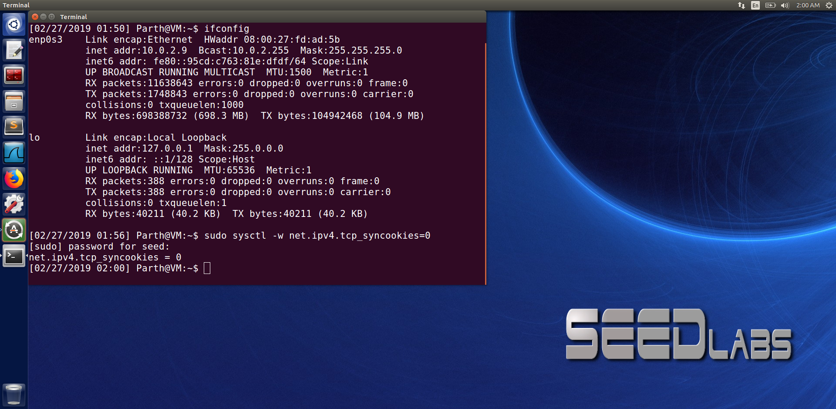

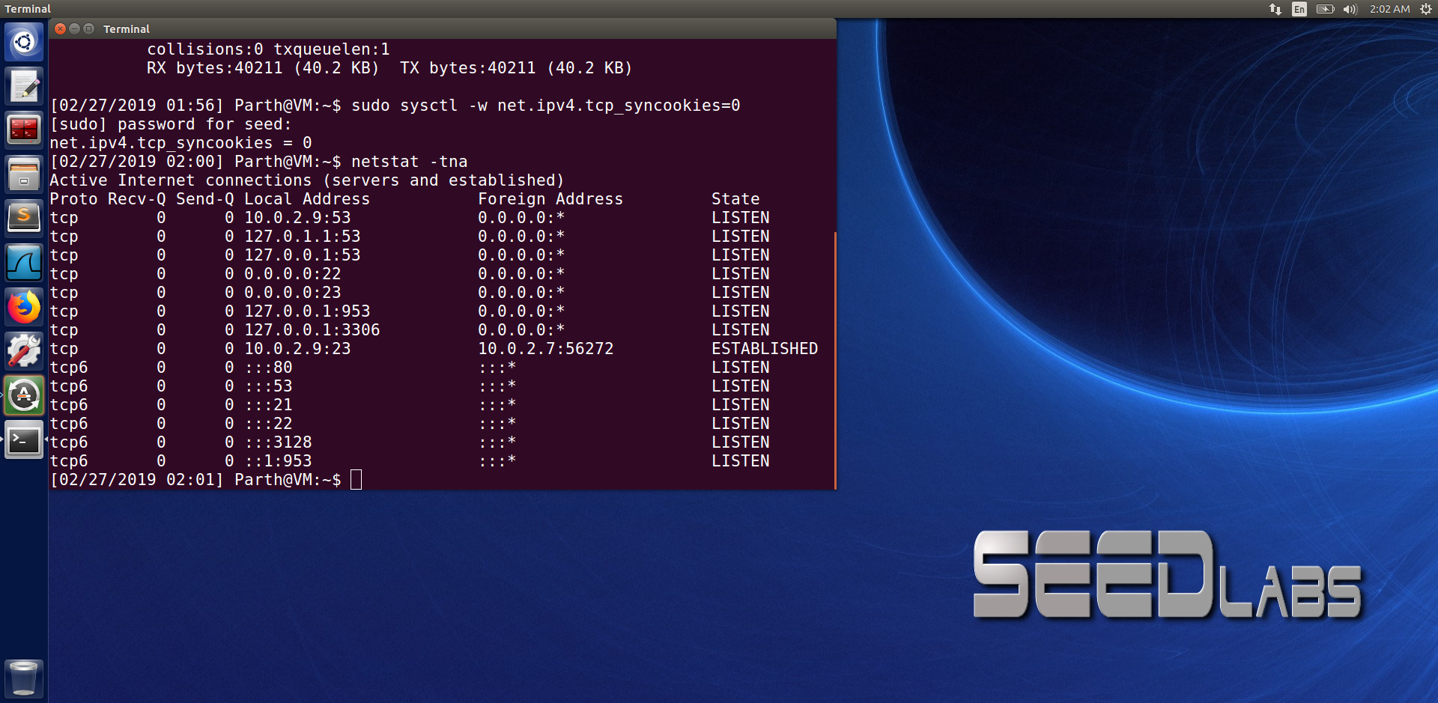

Now, we run the command ‘sudo netwox 76 -i 10.0.2.9 -p 23 -s raw’ from the attackers machine to the servers telnet server which is ’10.0.2.9’ and then from the servers machine we run the command ‘netstat -tna’ we can see that most of the connections are half opened connection indicated by SYN_RECV.

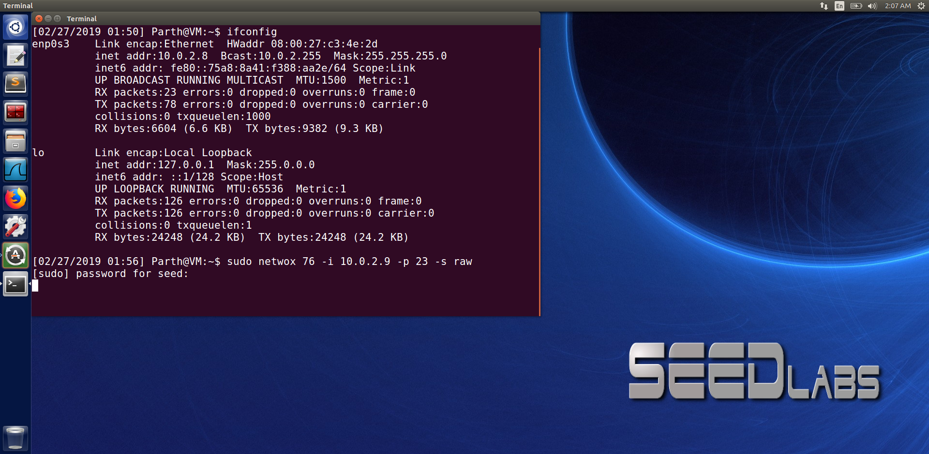

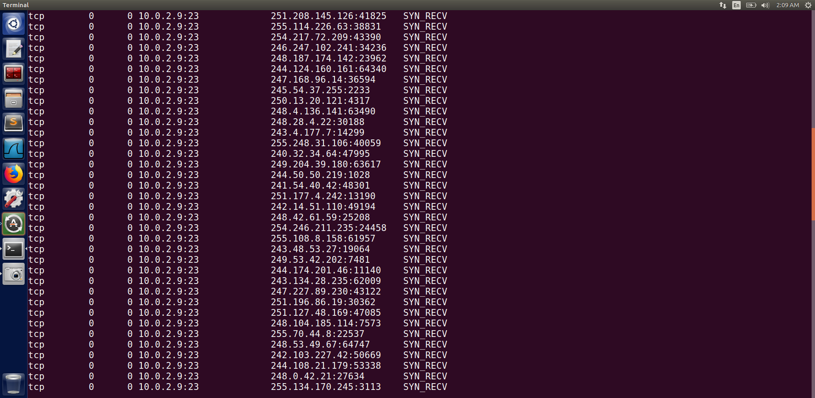

To make sure that our attack is successful we try to telnet again to the server. We can see that we are not able to do the telnet as it shows connection timed out.

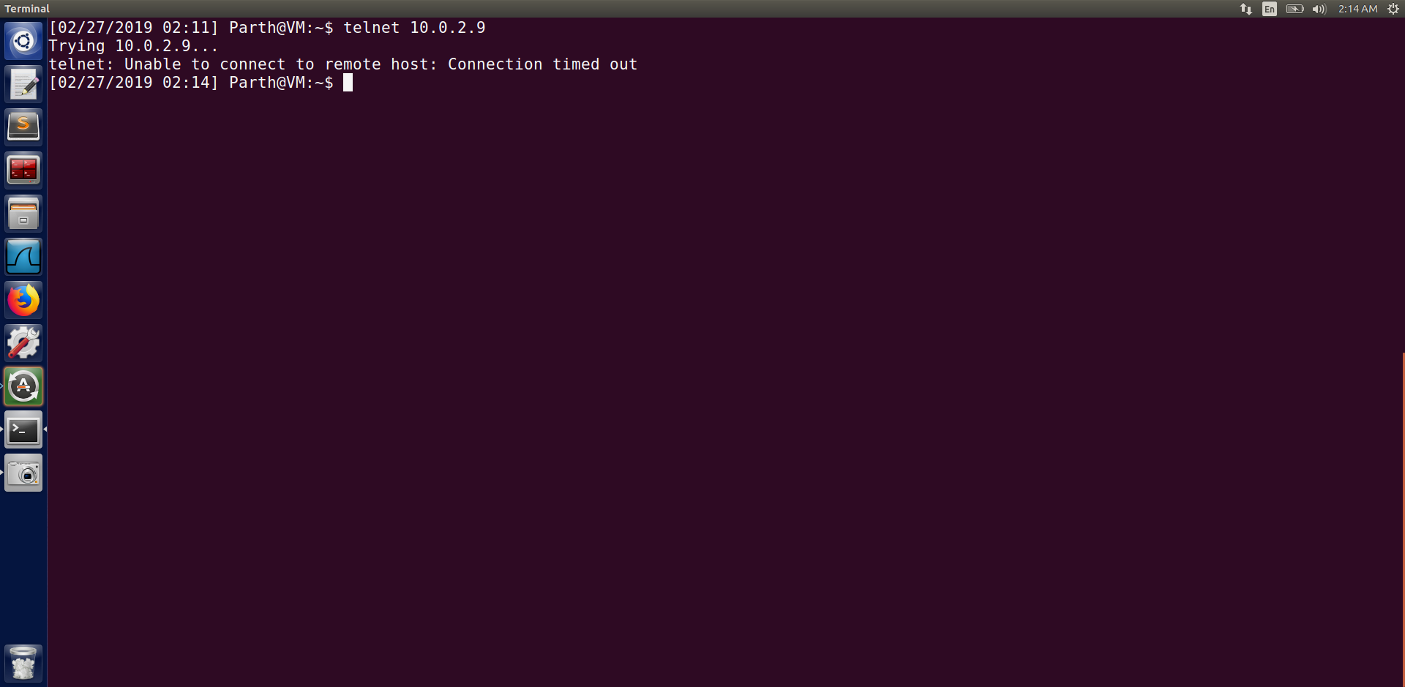

We try the same attack with the SYN cookie countermeasure ON.

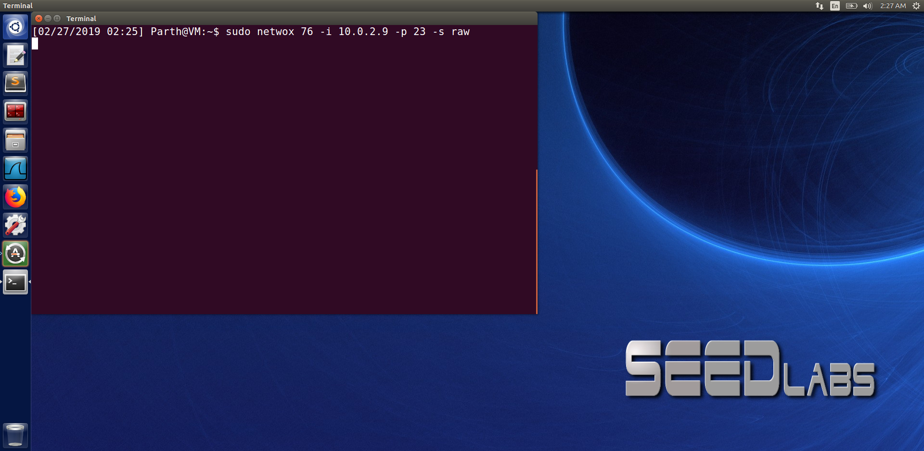

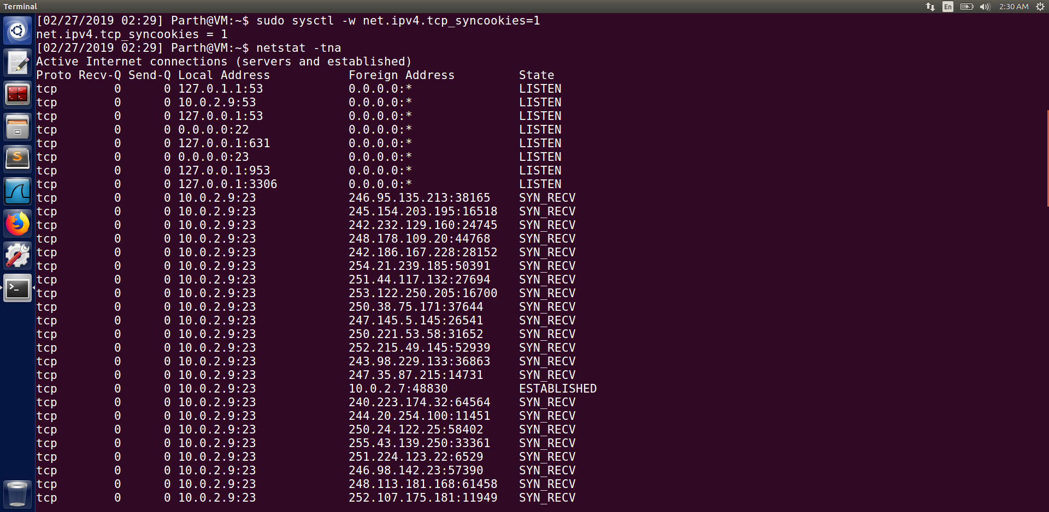

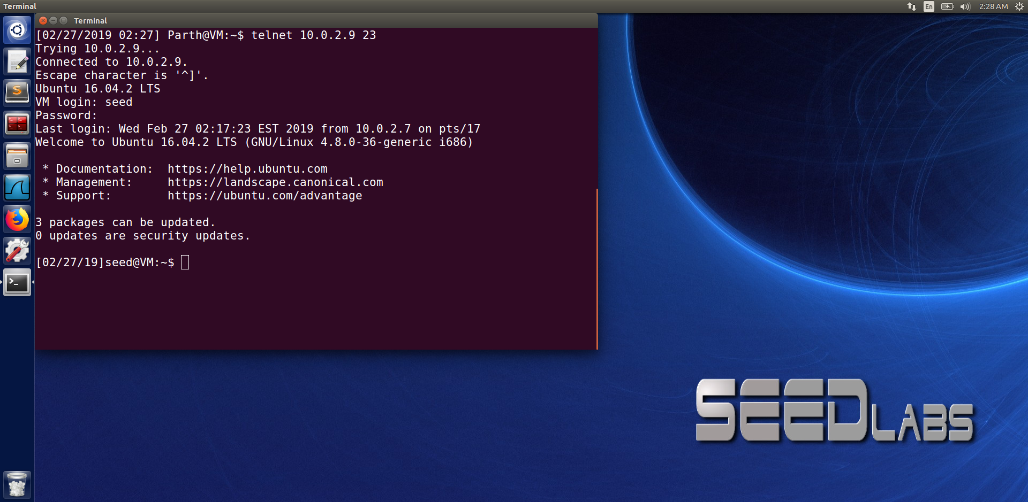

We can see that we were able to telnet the server even with SYN cookie turned to 1.

When the syn cookie mechanism is turned on, it does not allocate resources at all if the server has only received the SYN packet. Resources will only be allocated if the server has received the final ACK packet. This way the SYN flooding attack problem is solved.

**Task 2: TCP RST Attacks on telnet and ssh Connections**

In this task we first telnet from 10.0.2.7 to 10.0.2.9 at port 23 as seen from the wireshark output. We then analyse the wireshark to get the source port, sequence no and acknowledge no.

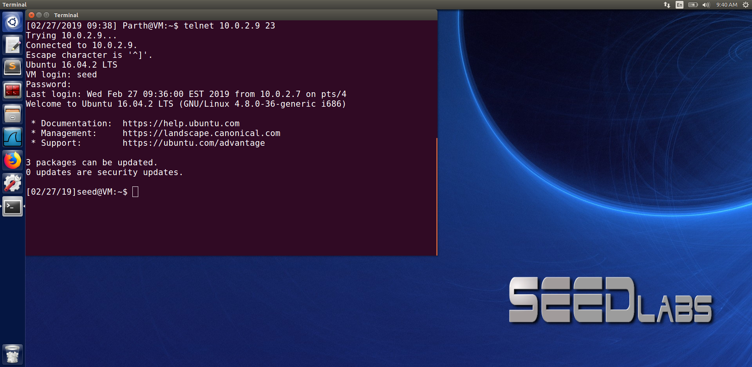

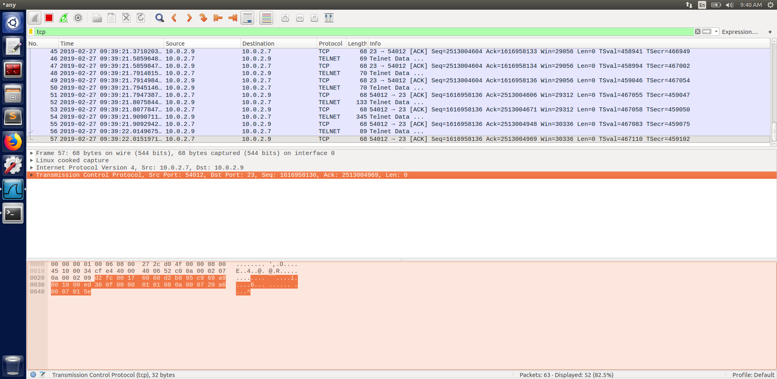

Now, we run the given code with source port, dest port, seq no same as that received on wireshark. And in the ack no we just add 1 to the number that we received in wireshark as seen in the below screenshot.

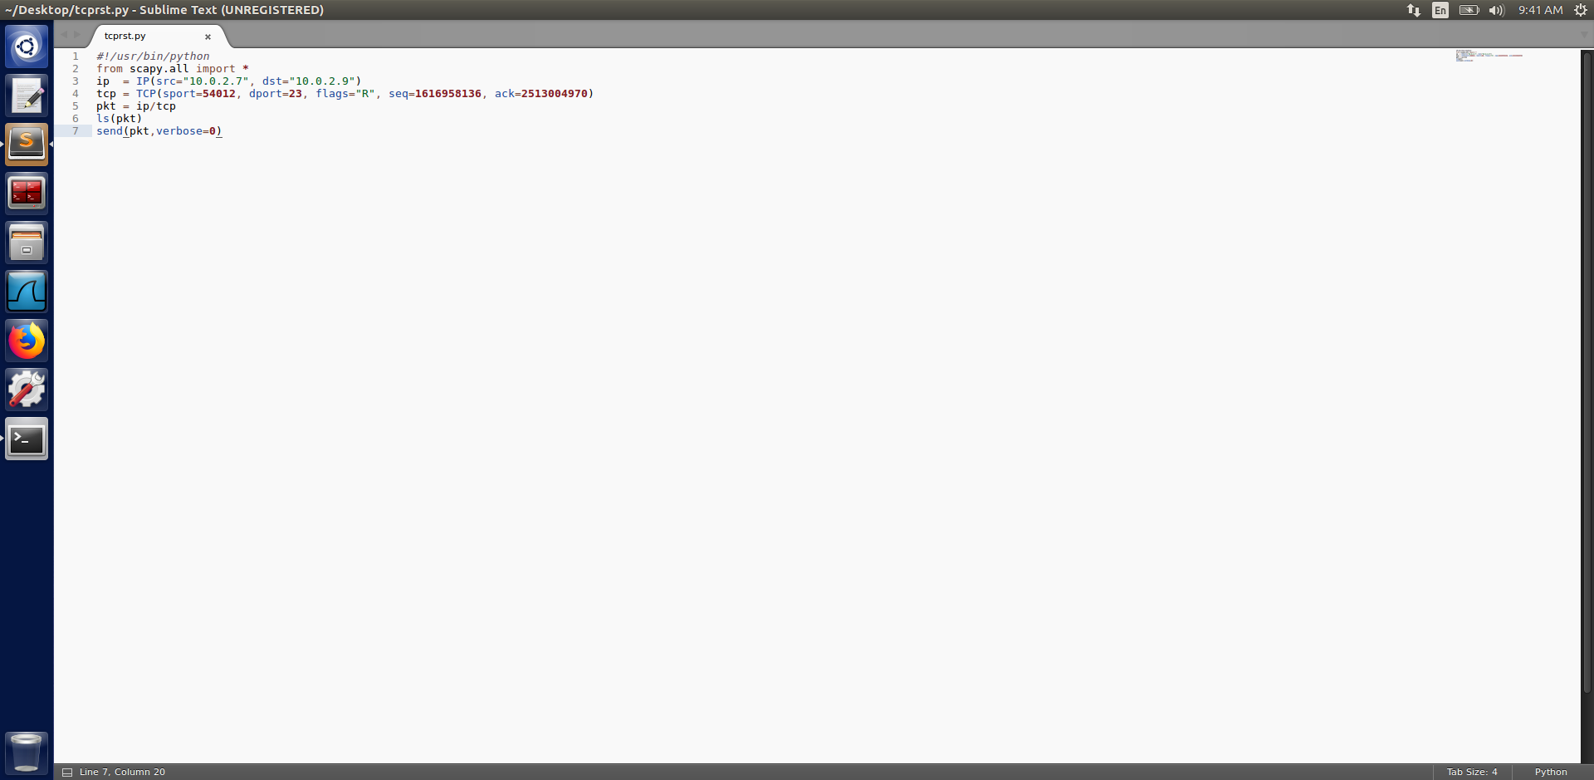

After running the code we analyze the wireshark again. We can see below that the reset bit is set to 1.

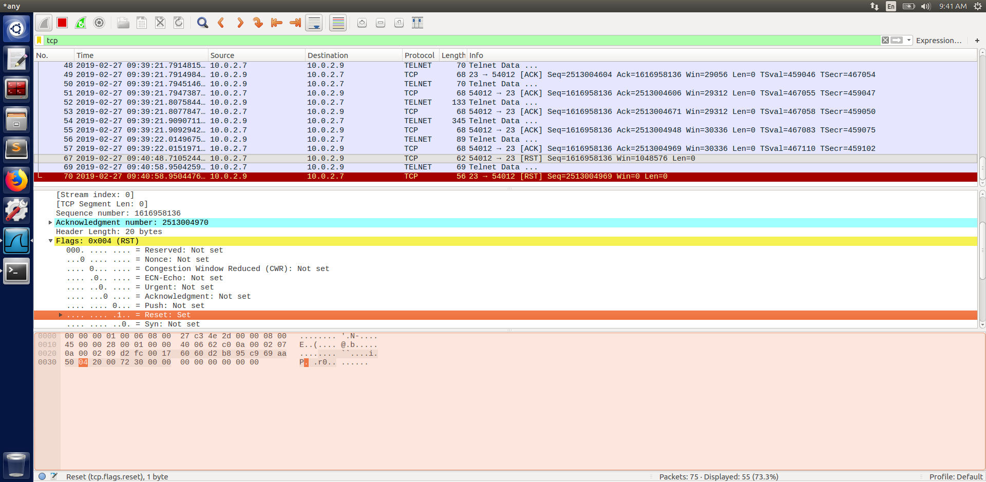

Since, the reset bit is turned to 1. It means that the connection from user to server has been disconnected and therefore, even without exiting from the users machine we can see below that the connection has been closed.

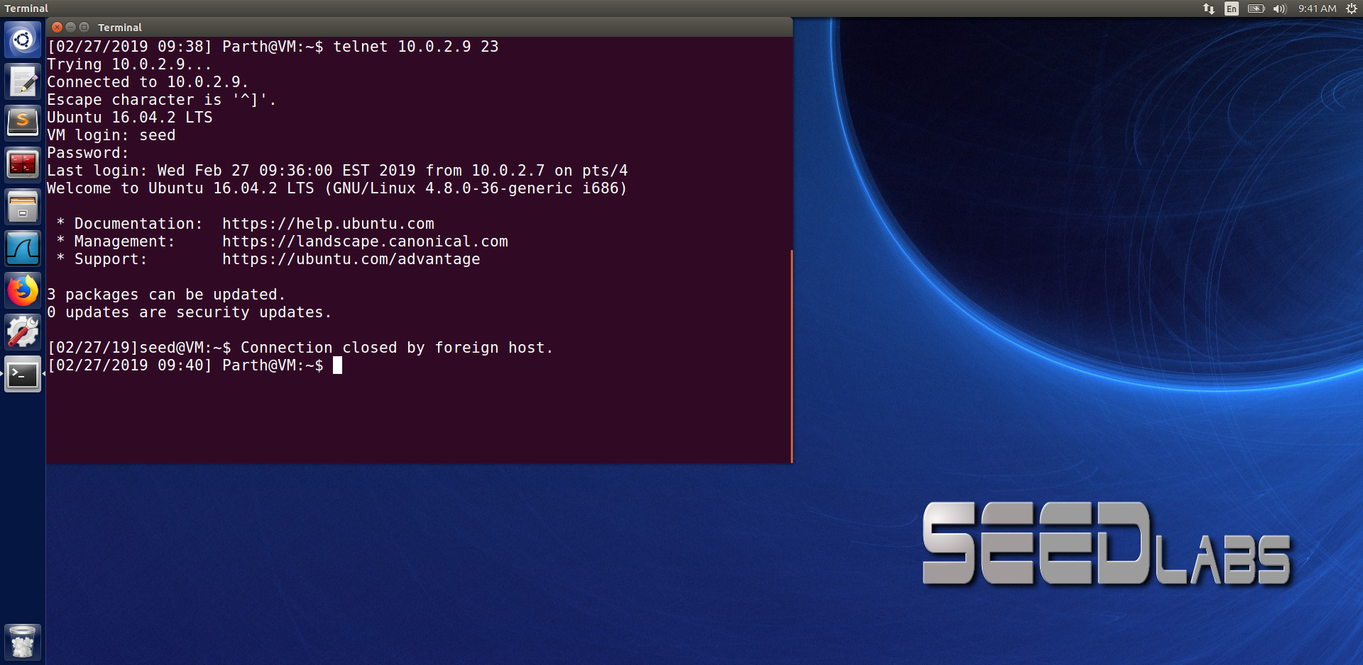

The fields in the spoofed packet i.e., source IP, source port, dest IP, dest port and seq no needs to be the same as those used by the connection else the receiver will discard the packet.

**SSH**

We have performed the same task as before but with the SSH connection.

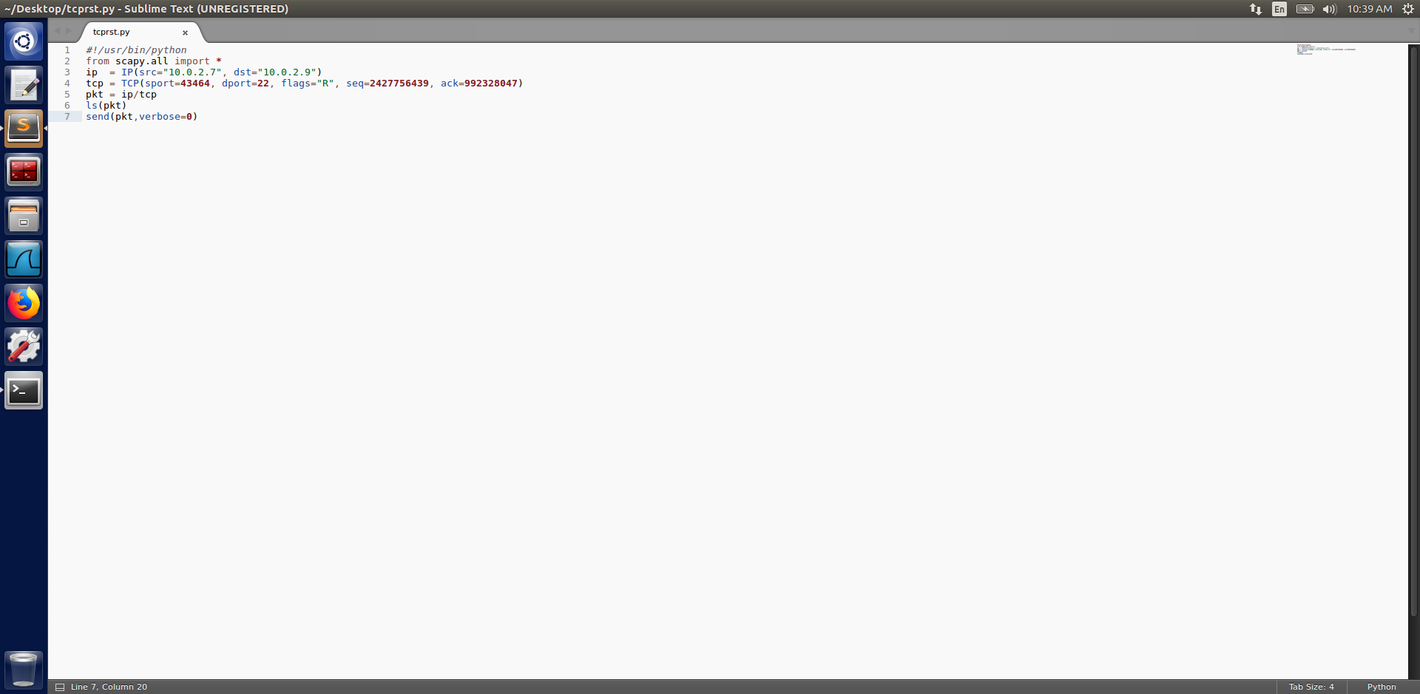

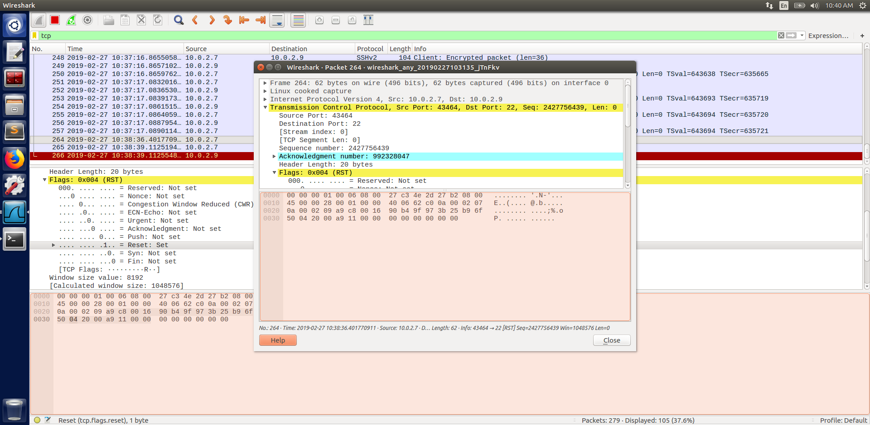

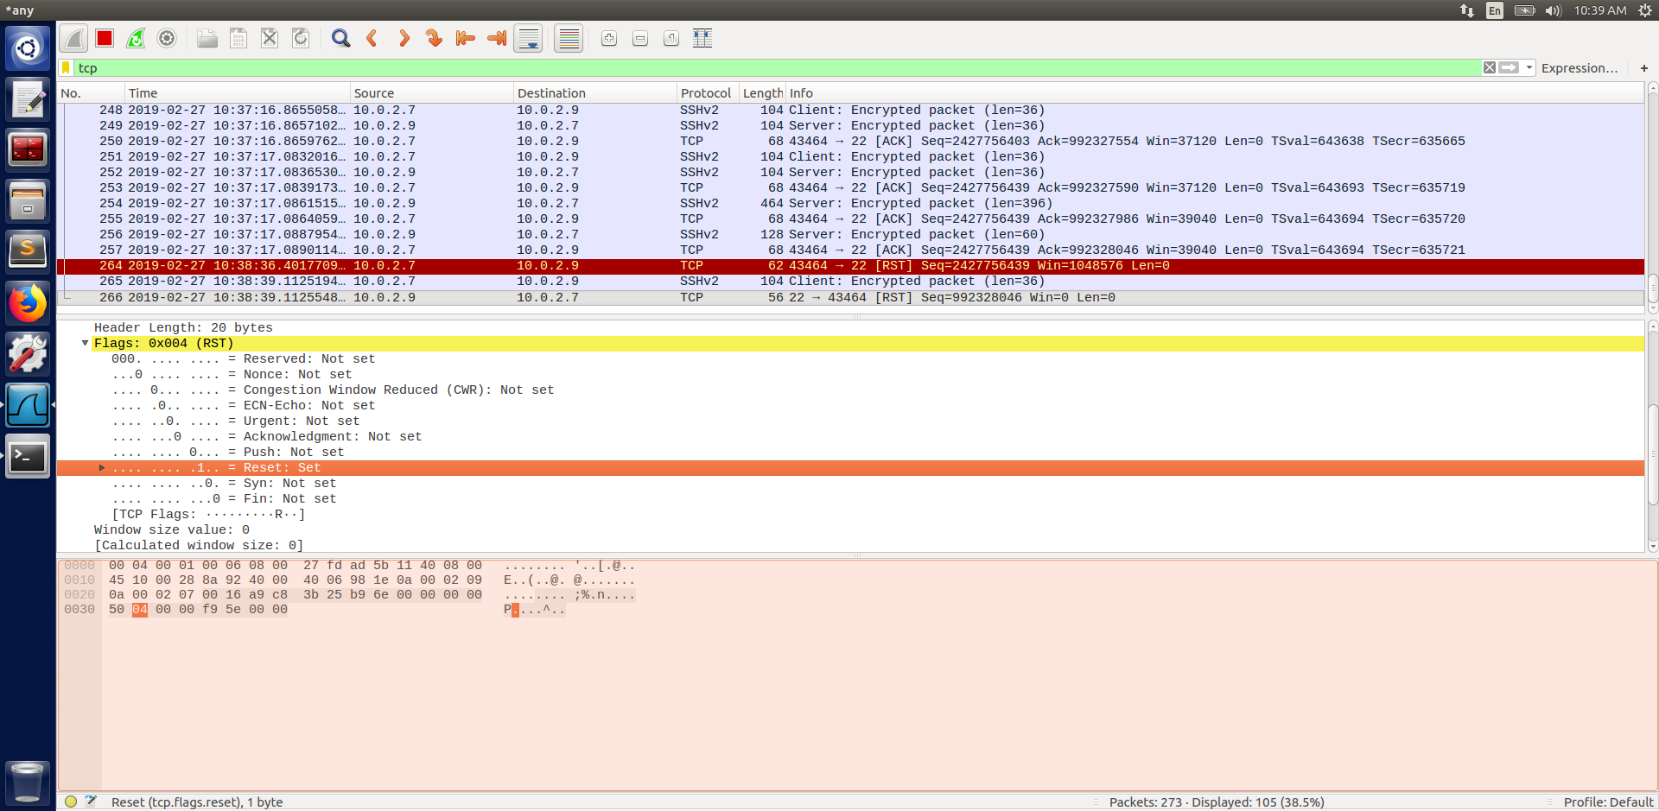

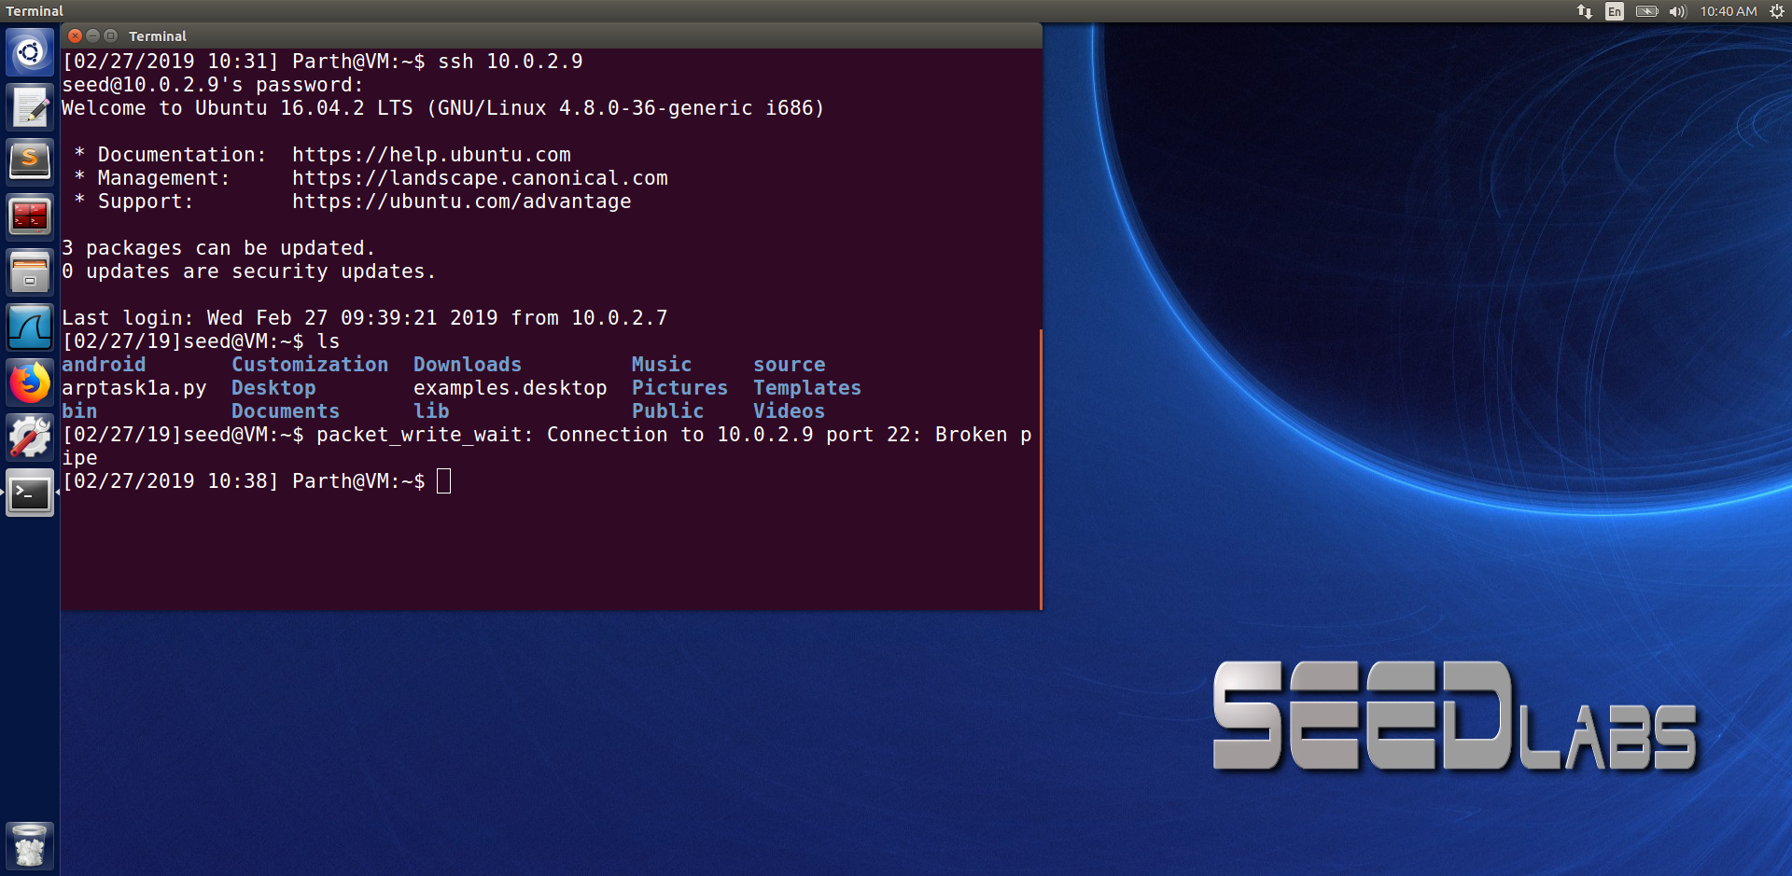

We performed the same task as the previous one but this time it was on encrypted TCP connection. SSH does the encryption at the transport layer i.e., only the data in TCP packets are encrypted. Since, the attack only spoof the header part and no data s needed for the RST packet our TCP RST attack was successful as seen from the screenshot above as we got the command as “Broken pipe” which indicates that we have successfully done the TCP RST attack on SSH as well.

**Task 3: TCP RST Attacks on Video Streaming Applications**

**(tried to manually attack on video streaming application)**

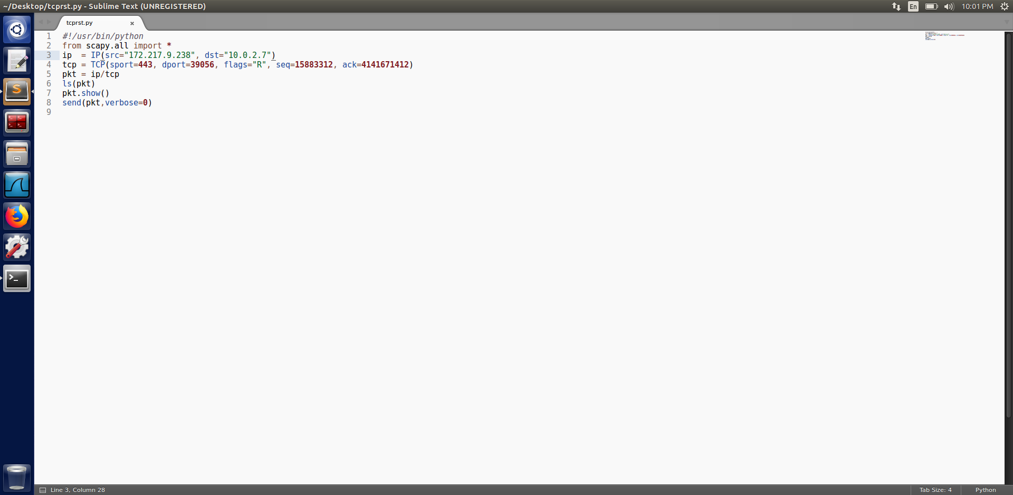

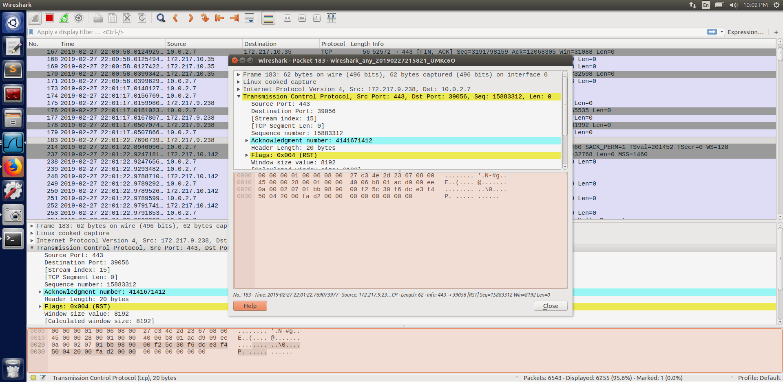

In this task we cannot stop the packets flowing between client and the server.

We tried to manually reset the connection.

We first noted all the important parameter that is to be put in the reset packet that is to be sent. We can see that somehow we were able to turn on the reset bit for a fraction of time. It might have caused delay for few seconds/milliseconds while watching the video.

**Using Netwox**

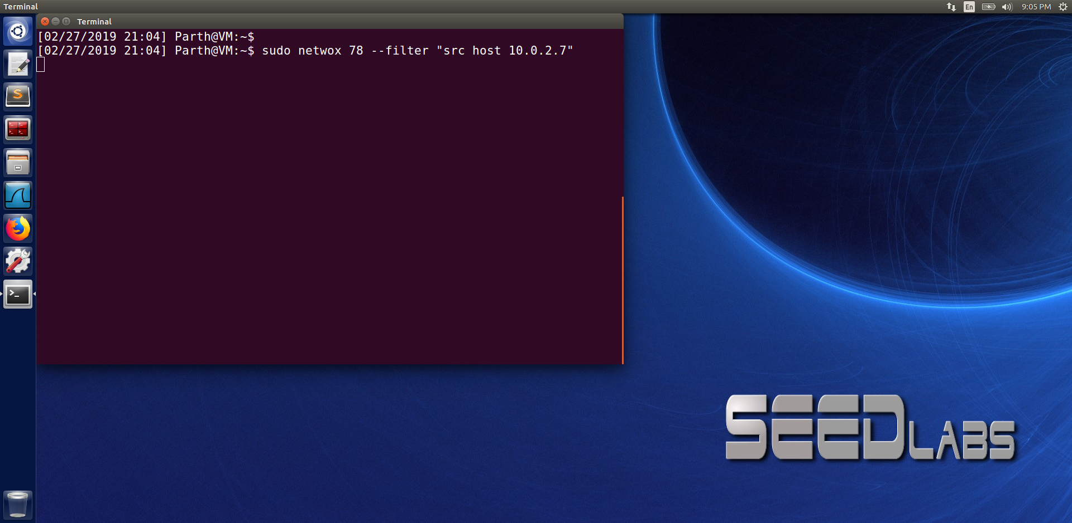

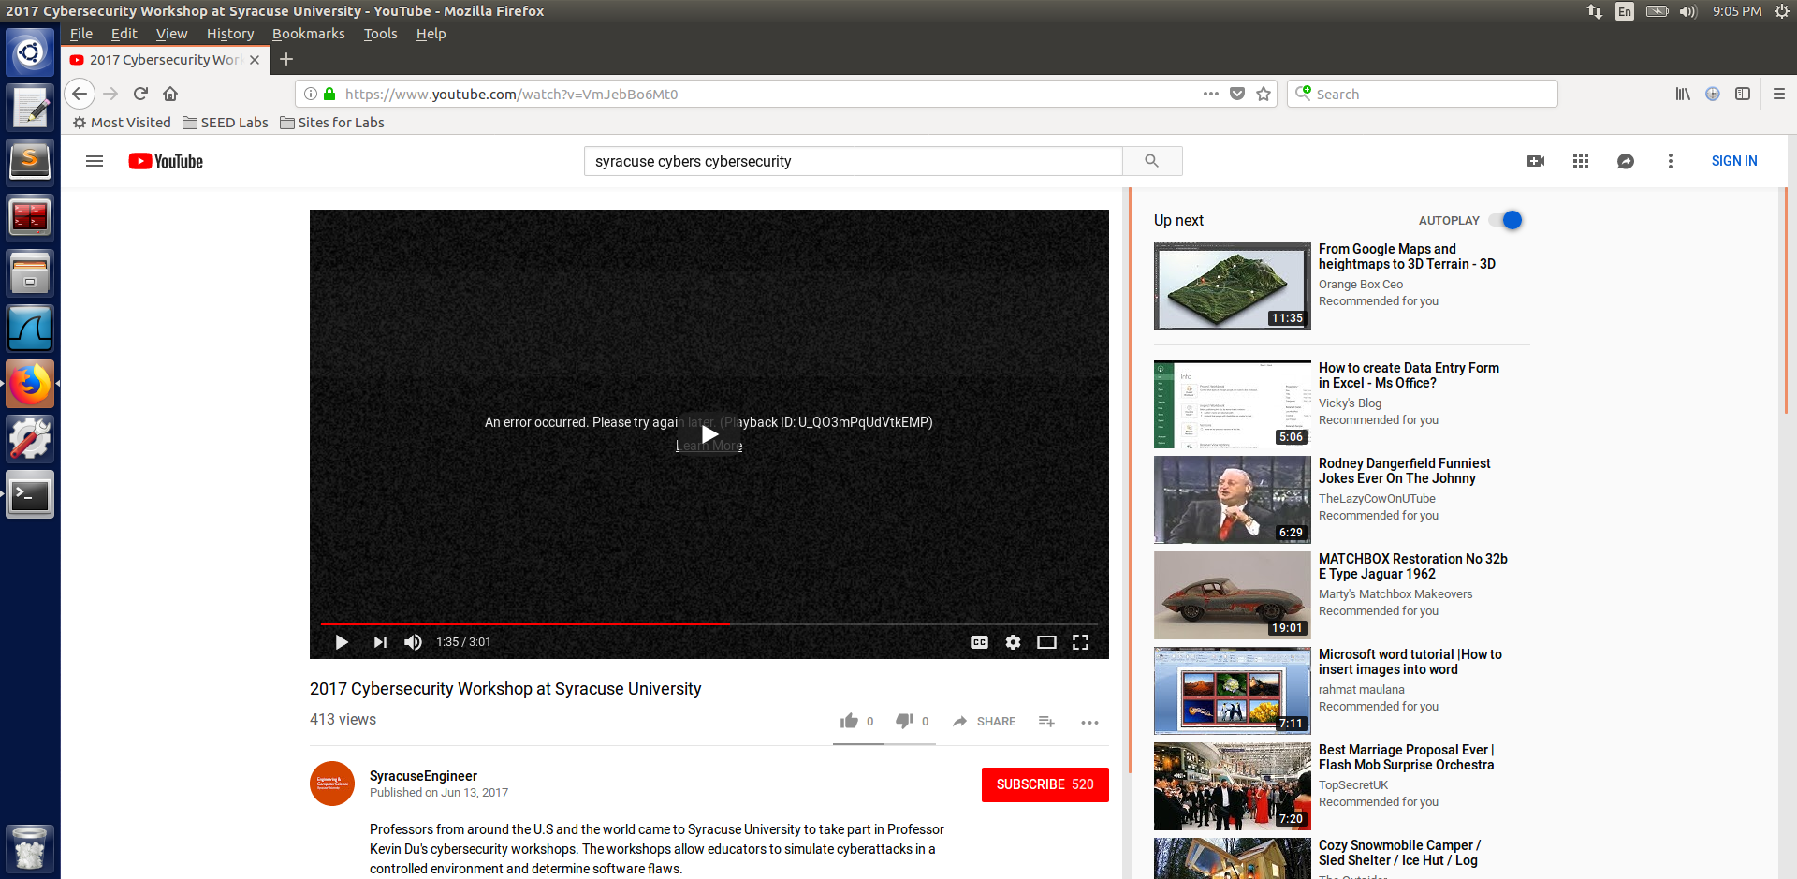

In this task we use the command sudo netwox 78 –filter “src host 10.0.2.7”.

When we execute this command it resets each packet that comes from 10.0.2.7 i.e., resetting all the connection, including the video streaming.

In this task we need to be careful that we need to reset our own machine. If we try to mistakenly reset the youtube server it might assume as suspicious activity and block your IP.

**Task 4: TCP Session Hijacking**

In this task we first create a telnet connection from 10.0.2.8 to 10.0.2.9.

In the server machine we created a file named secret where we wrote “You are hacked.”

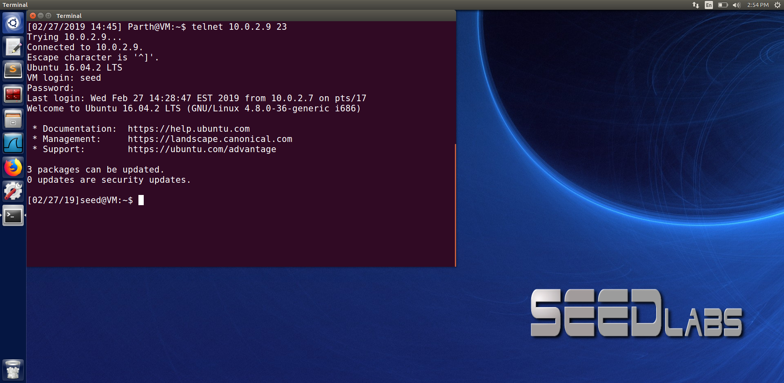

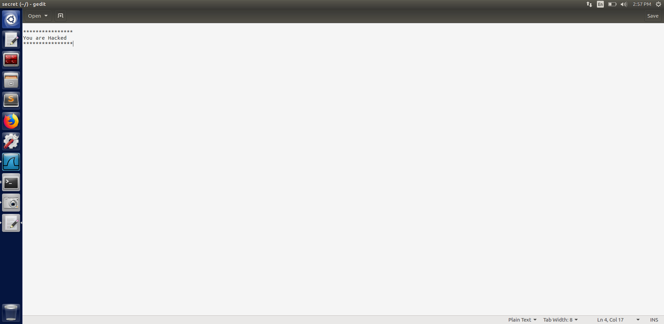

Similar to the previous task we noted the src port, dest port, seq no and ack no and was correspondingly put in the code. Apart from that we also write the cat command (it is defined with ‘data’) to redirect the content of the secret file to the attackers machine. ‘/dev/tcp’ file is a pseudo device which creates a TCP connection with the TCP server listening on port 9090 of 10.0.2.8 and sends the data via the connection.

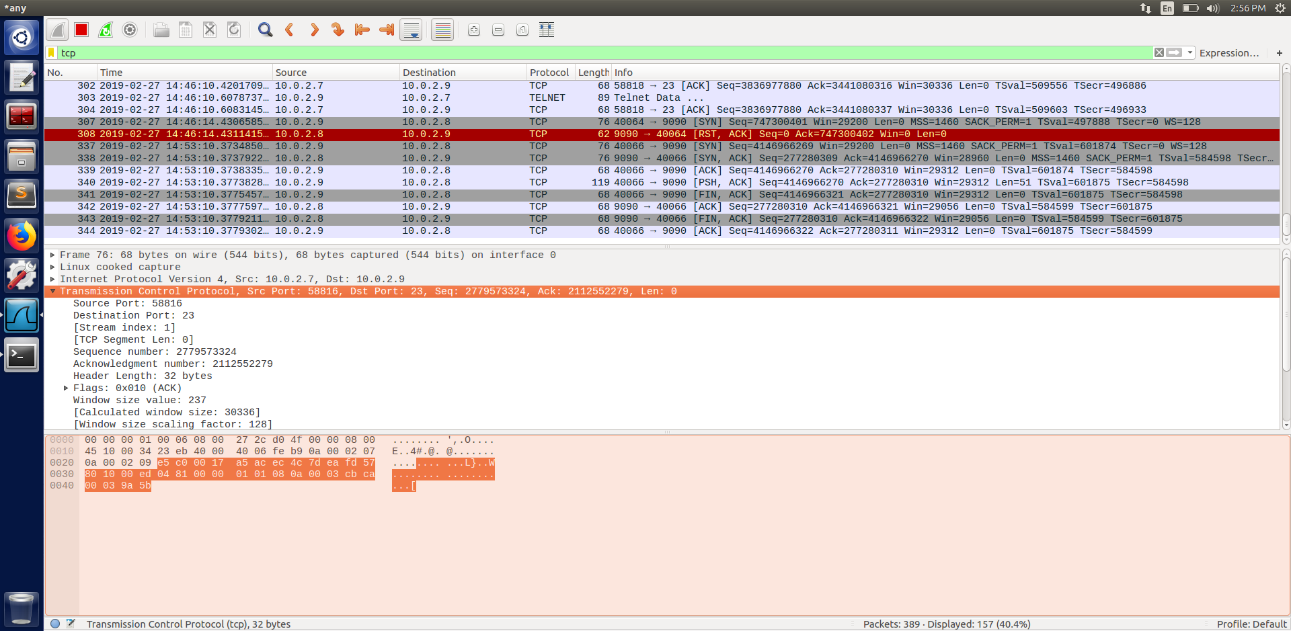

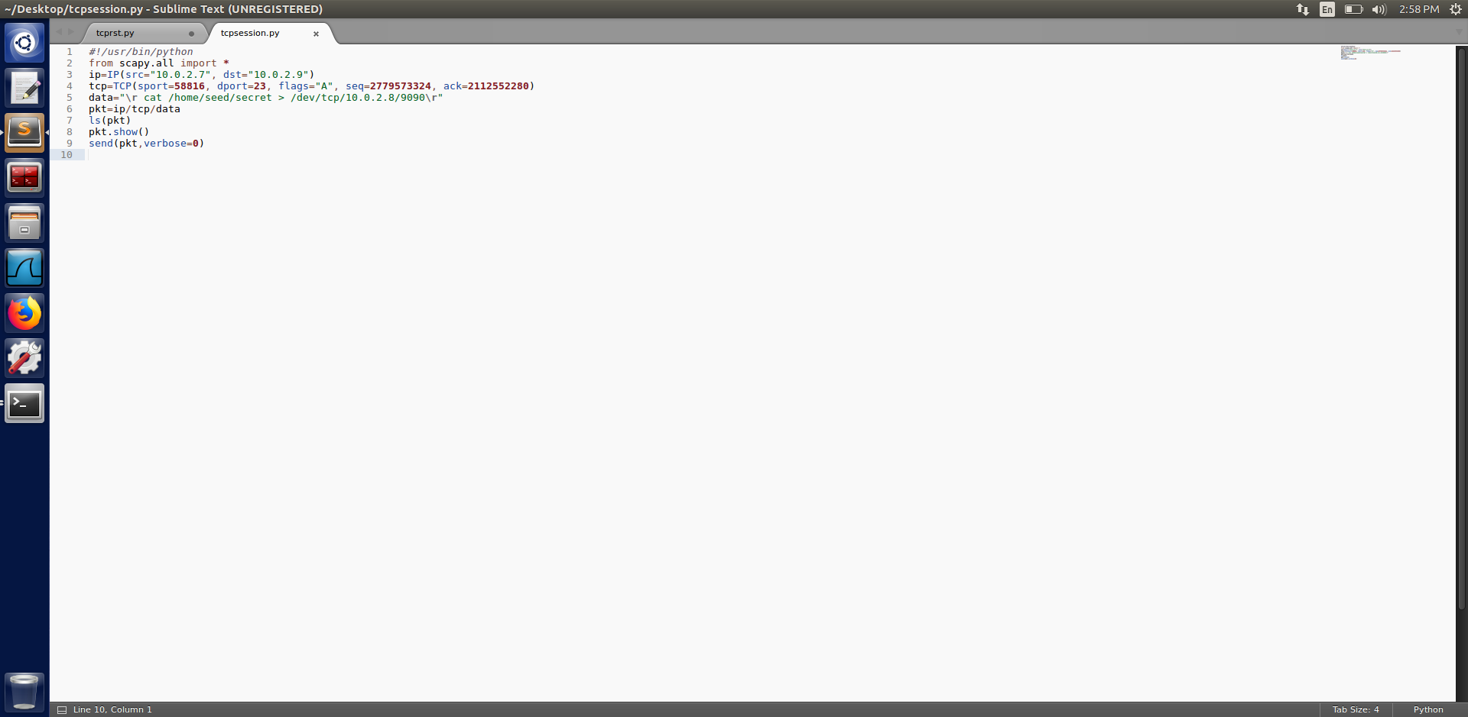

As soon as we run the cat command the attacker machine gets the content of the file as seen from the screenshot below.

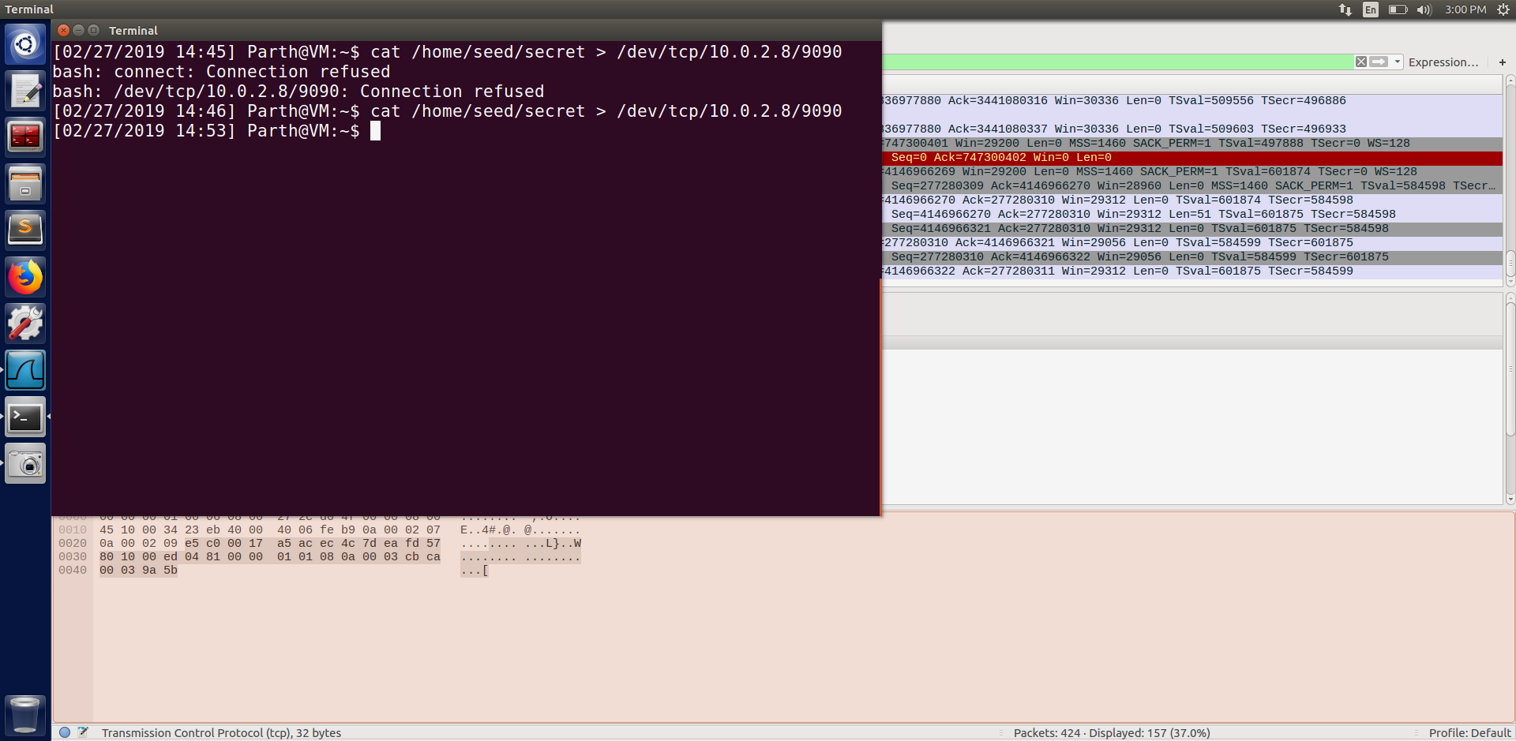

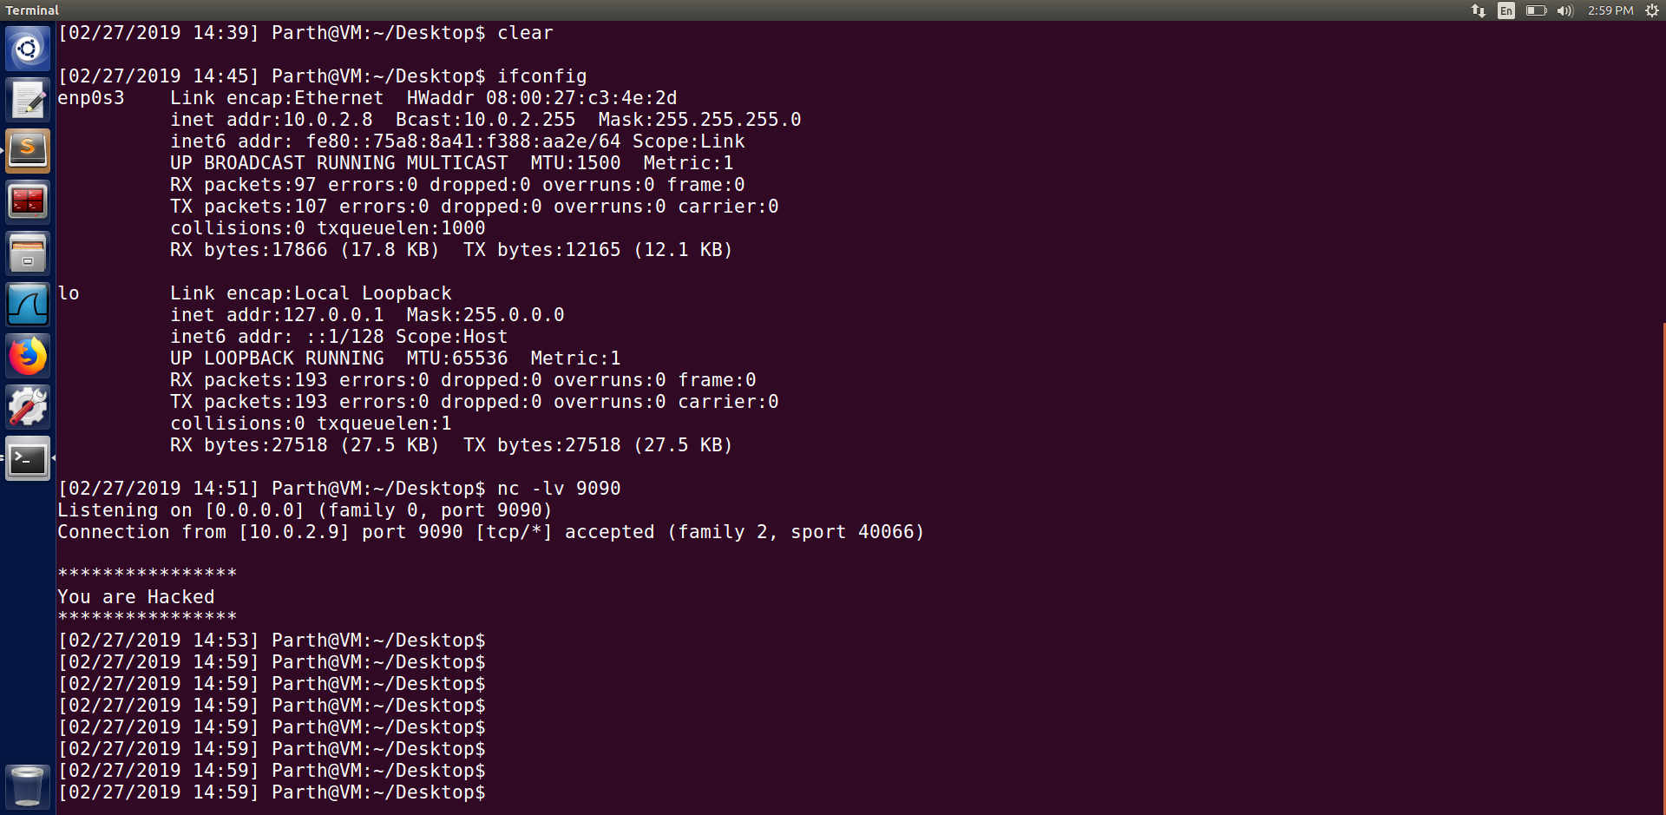

**Task 5: Creating Reverse Shell using TCP Session Hijacking**

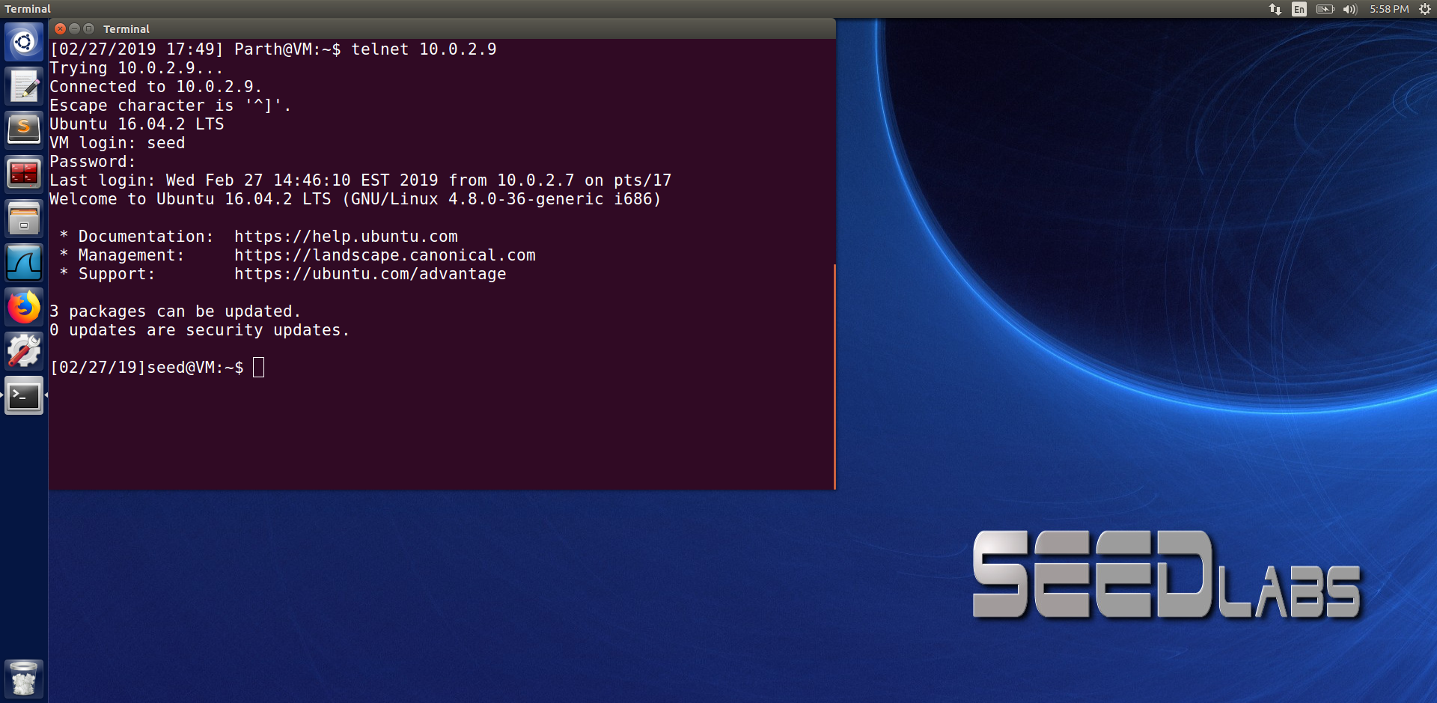

p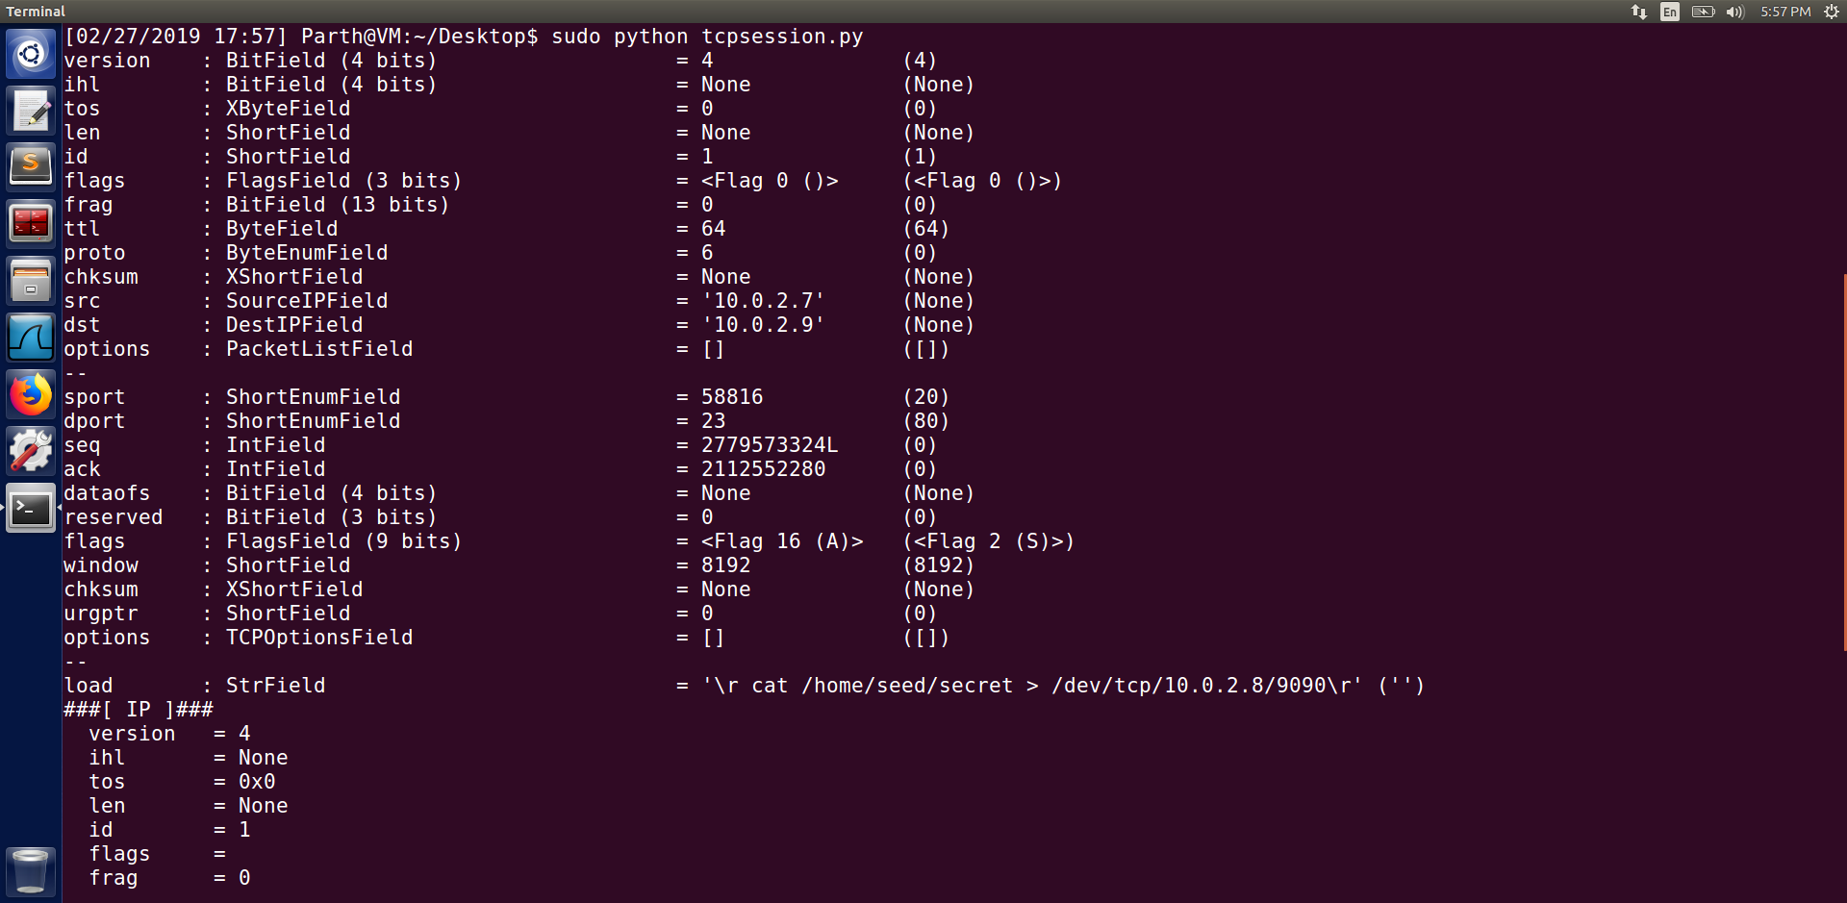

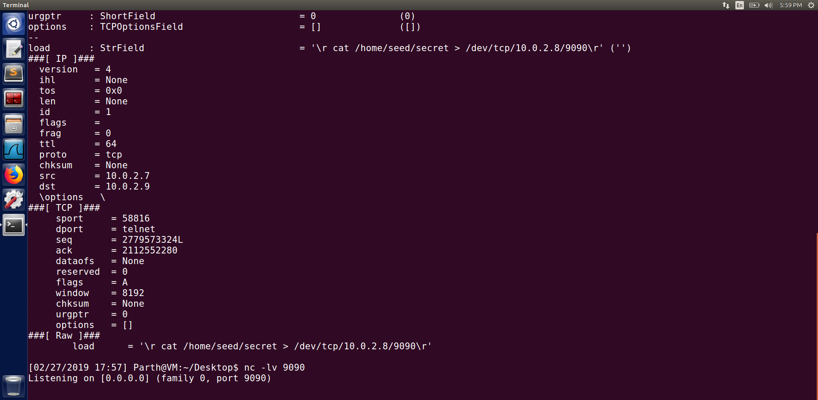

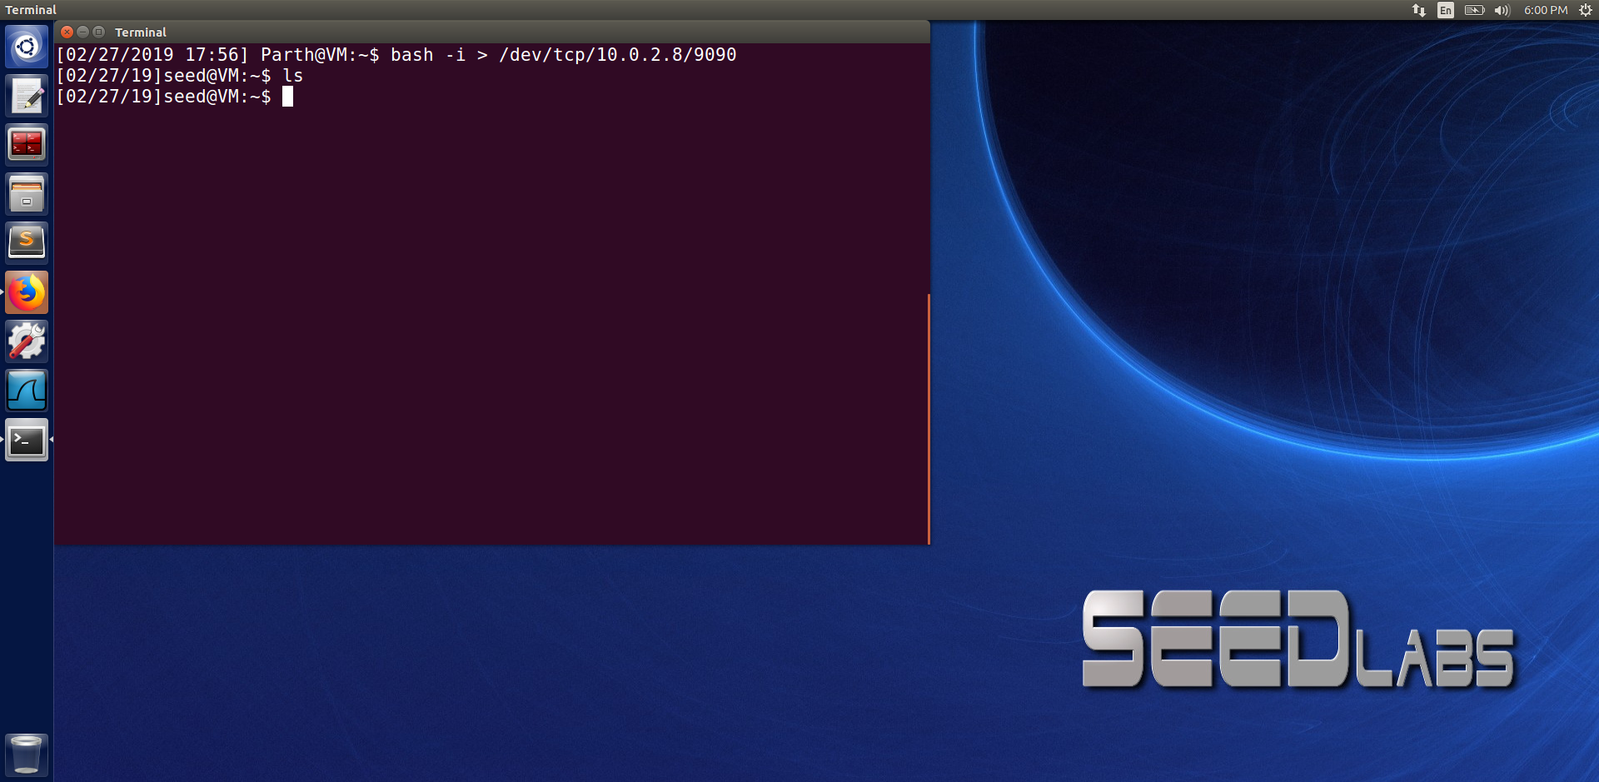

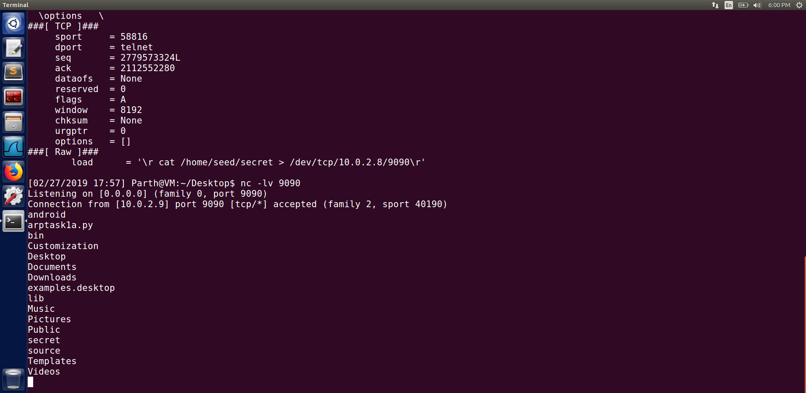

This task is similar to task 4 except that instead of running the cat command we run the shell program on the server machine. From the above screenshot we can see that we were successful in creating reverse shell and that we were able to connect the server machine to the attackers machine.